한국통계학회 생물통계연구회 춘계 정기세미나
한국통계학회 생물통계연구회에서 Department of Biostatistics, University of Copenhagen, Copenhagen, Denmark 의 Per Kragh Andersen 교수님과 Thomas Scheike 박사님을 모시고 아래와 같이 춘계 정기세미나를 개최합니다. 관심 있으신 연구자 여러분들의 많은 참석을 바랍니다.
일시: 2011년 3월 18일 금요일 오후 4:00-6:00
장소: 서울대학교 보건대학원 (관악캠퍼스 221동) 113호 강의실 (1층 강당)

연자 및 제목:
- Prof. Per Kragh Andersen (University of Copenhagen, Denmark )

Competing risks and time-dependent covariates

- Dr. Thomas Scheike (University of Copenhagen, Denmark )

Multivariate competing risks data
강의 초록:

- Kragh Andersen: "Competing risks and time-dependent covariates"
In survival analysis, hazard regression models enable inclusion of time-dependent covariates. However, when including internal/endogenous covariates, the one-to-one correspondence between hazard function and cumulative survival probability is lost. This problem persists in models for competing risks. In this paper we explore some methods by which cumulative incidences in competing risks models may be estimated in the presence of an internal time-dependent covariate. One method is based on an extension of the competing risks multi-state model while the other builds on van Houwelingen's "landmark" approach (Scand. J. Statist., 2007). Data from a bone marrow transplantation study are used to illustrate the techniques.

- Thomas Scheike: "Multivariate competing risks data"
I will consider semiparametric random effects model for multivariate competing risks data when the failures of a particular type are of interest. Under this model, the marginal cumulative incidence functions follow a generalized semiparametric additive model. The associations between the cause-specific failure times can be studied through dependence parameters of copula functions which are allowed to depend on cluster level covariates. A cross-odds ratio type measure is proposed to describe the associations between cause-specific failure times and its relationship to the dependence parameters are explored. We develop a two-stage estimation procedure where the marginal models are estimated in the first stage and the dependence parameter is estimated in the second stage. The large sample properties of the proposed estimators are derived. The proposed procedures are applied to Danish twin data to model the cumulative incidence for the age of natural menopause and to investigate the association in the occurrence of natural menopause between monozygotic and dizygotic twins.

세미나 장소 오시는 길

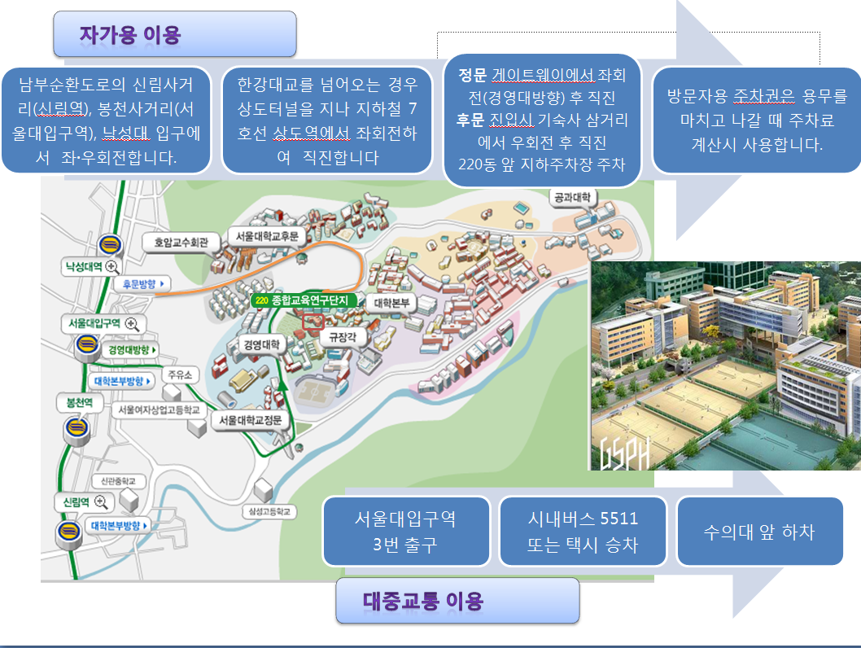
장소 문의: 010-5379-2366 (강민진)
010-8296-2222 (김샛별)

